7.5_1 Dijkstra Optimized
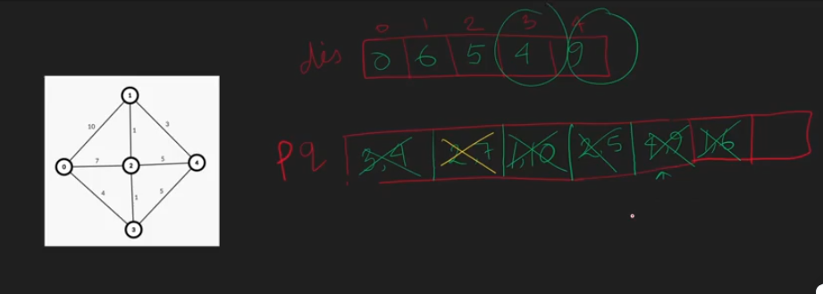

7.5_2 Dijkstra Optimized Animated
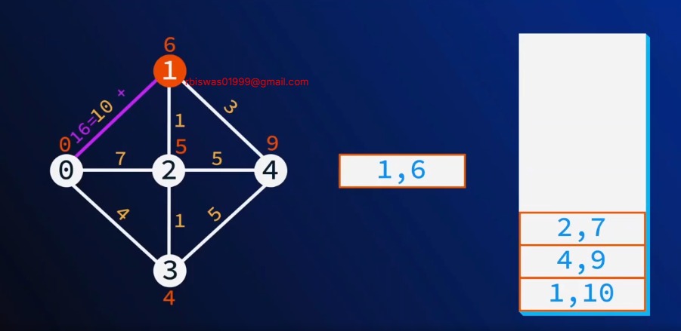

7.5_3 Priority queue of pairs
Generally Priority queue -> keep the elements / give the priority of the first value [for pair]
So for us to give the second value (as we have used dis as second value) we can have 2 options :
- Custom compare
- Directly keep the second(dis) value in the first , and node in the second

7.5_4 Dijkstra Optimized Implementation
#include<bits/stdc++.h>
using namespace std;

vector<pair<int, int>> adj_list [105];
int dis[105];

void dijkstra(int src){
priority_queue<pair<int, int>,vector<pair<int, int>>, greater<pair<int, int>>>pq;
pq.push({0, src});
dis[src] = 0;
while (!pq.empty())
{
pair<int, int> par = pq.top();
pq.pop();
int par_node = par.second;
int par_dis = par.first;

// for(pair<int, int> child: adj_list[par_node]){
for(auto child: adj_list[par_node]){
int child_node = child.first;
int child_dis = child.second;
if(par_dis + child_dis < dis[child_node]){
dis[child_node] = par_dis + child_dis;
pq.push({dis[child_node], child_node}) ;
}
}
}

}

int main(){
int n, e;cin>>n>>e;

while (e--)
{
int a, b, c;cin>>a>>b>>c;
adj_list[a].push_back({b,c});
adj_list[b].push_back({a,c});
}

for (int i = 0; i < n; i++)
{
dis[i]=INT_MAX;
}

dijkstra(0);

for (int i = 0; i < n; i++)
{
cout<<i<<" -> "<<dis[i]<<endl;
}

return 0;
}

// input:
// 5 8
// 0 1 10
// 1 2 1
// 0 2 7
// 0 3 4
// 2 3 1
// 3 4 5
// 1 4 3
// 2 4 5

// output:
// 0 -> 0
// 1 -> 6
// 2 -> 5
// 3 -> 4
// 4 -> 9

7.5_5 Complexity of Dijkstra optimized
O( (V+E)logV )
= O( (E+E)logV )
= O( 2ElogV )
= O( ElogV )

